**Project Report**

# On

#### **“Olympic Data Analysis”**

#### **Submitted to**

**Rashtrasant Tukadoji Maharaj Nagpur University Nagpur**

In the partial fulfillment for the Award Degree of

**MASTER OF COMPUTER MANAGEMENT**

#### **Submitted By**

**“RAJJAT KUMARE1”**

**“KRISTINA ANNAPAREDDY2”**

**“LOKESH SONARE3”**

##### Under the Guidance of

**Prof. S. S. Anwaney**



**Department of Computer Education**

**Dhanwate National College**

**Congress Nagar, Nagpur - 440 012.**

**2021 – 2022**

*ShriShivaji Education Society, Amravati’s*

**Dhanwate National College**

**Department of Computer Education**

**CERTIFICATE**

This is to certify that the Project entitled **“Title of your project”** submitted by projectee Rajjat Kumare, Projectee Kristina Annapareddy, Projectee Lokesh Sonareis in partial fulfillment of the requirements for the award of the **MASTER of Computer MANAGEMENT** from Rashtrasant Tukdoji Maharaj Nagpur University and is a bonafide record of the work done by him at Dhanwate National College, Nagpur during the academic year 2020 - 21.

Guide

**(Prof. S. S. Anwaney)**

Place: Nagpur

Date:

**Principal**

Dhanwate National College

Nagpur

**Internal Examiner External Examiner**

**DECLARATION**

To,

**The Principal,**

Dhanwate National College,

Congress Nagar,

Nagpur – 440 012.

Respected Sir,

We the undersigned, hereby declare that the work entitled **“Olympic Data Analysis”** developed and submitted by us is ours original work. The system presented here is developed by us independently and has not been duplicated from any other source.

We understand that any such copying is liable to be punished in any way the University deem fit.

Place: Nagpur

**“RAJJAT KUMARE1”**

**“KRISTINA ANNAPAREDDY2”**

**“LOKESH SONARE3**

**ACKNOWLEDGEMENT**

#### We wish to express my sincere thanks to the honorable **Dr. J. D. Wadte,** Principal, Dhanwate National College, Congress Nagar, Nagpur, for providing me varieties of opportunities, infrastructural facilities and inspiration to gather professional knowledge and material without which it would have been impossible to complete this hard task.

#### We take this opportunity to express our deep gratitude and whole hearted thanks to us **Project guide Guide (Prof. S. S. Anwaney)** for his guidance throughout this work. Weare very much thankful to him for his kindness, encouragement and the valuable time, which he has devoted to me.

We wish to thanks all those, who have helped me in us way or the others in bringing out this project successful.

**“RAJJAT KUMARE1”**

**“KRISTINA ANNAPAREDDY2”**

**LOKESH SONARE3**

**INDEX**

1. Brief Review of Project
   1. Introduction
   2. Aims and Objectives
2. Preliminary System Analysis
   1. Identification of needs
   2. Tools, Components and Platform
   3. Study of Existing System
3. Project Category Software/Hardware Requirements
   1. Hardware Specification
   2. Software Specification
   3. Language Used
4. Detail Design System
   1. Data Flow Diagram

**INTRODUCTION**

Present system of ”OLYMPIC DATA ANALYSIS” is handled manually which is a tedious job & time consuming job, this is so because everyday many analysis take place and each time we have to done to do complete analysis in respective analyze and registers in which new records are maintained , this analysis report shows how sports analytics crucial, ultimately resulting in chaos.

the web app dashboard developed eases the job of data analysis by making the maintenance of registers computerized and producing the required information quickly by withdrawing few outputs.

with the help of this project the job of the become easy by making maintenance of register computerized. A very adequate data visualization will be established.

In medal tally form we can display all information about overall Olympic medals such as medal tally. We can draw insight of data report using EDA(Exploratory Data Analysis). In the medal tally the module is used to show the tally analysis of overall medal counting which show when and which year it had won it

In this dashboard, my goal is to shed light on major patterns in Olympic history. How many athletes, sports, and nations are there? Where do most athletes come from? Who wins medals? What are the characteristic of the athletes (e.g., gender and physical size)?

In country-wise analysis, we can display data visualization graph how to country were performing in history in Olympic games. Also shows the top Athletes of country.

**AIM & OBJECTIVE**

* This data analysis dashboard main objective is to draw insight of the sports industry and help sports person to make decision about the game career.
* This dashboard helps sports industry to make better decision that which age group men and women are participating in sports faculty and which country paying more attention to their sport players.
* It also helps in sports analytics to achieve their objectives and customizes the all record and maintain it to show the visual graph to understand the data
* Using the data visualization plot to define the data pattern. To clarify purpose of sports industry.
* This dashboard shows the distribution of players age according to their country and what ideal age is achieve more gold medal in games.

**IDENTIFICATION OF NEED**

One must know what the problem is before it can be solved. It helps to find out real problem of the existing system without clear understanding of the problem the further work will be wastage of time and energy. So it is necessary to identify the actual problem. The initial investigation must satisfy the following conditions:

1. What effect does the host country have in the medals won at the olympic?
2. Is the age of winning Olympics changing?
3. How many countries were participated in these?
4. Overall Medal Tally

The success of the system depends largely on how accurately a problem is defining thoroughly investigation`& properly carried out through the choice of the solution here mostly concern with the user need rather that what he or she wants.

**PRELIMINARY ANALYSIS**

Preliminary Analysis deals with investigations on the basic of initial stage of the project. In this stage of project development we have required various information related to data.

In this project “Olympic Data Analysis” we have collect information form the required website called ‘kaggle’.

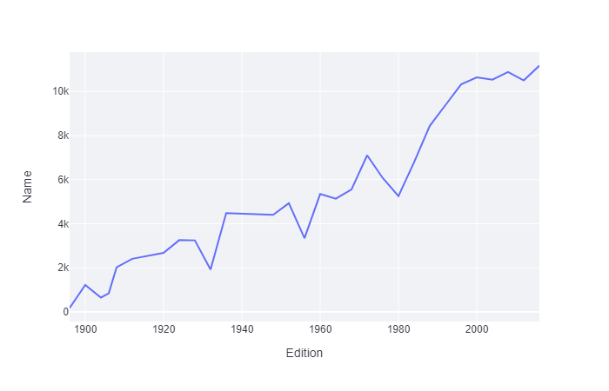

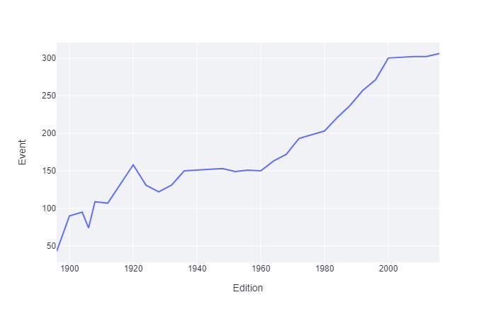

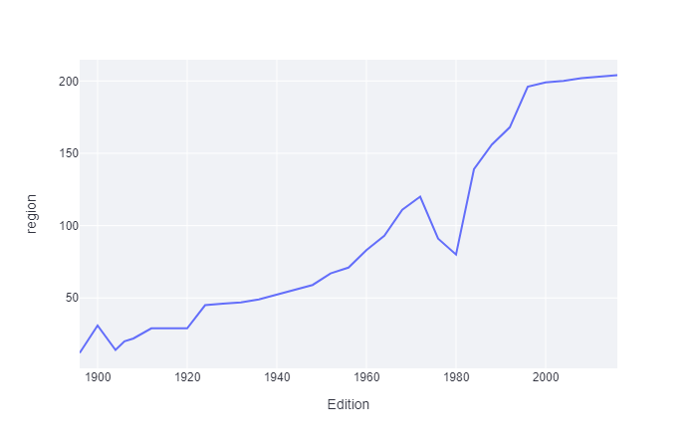

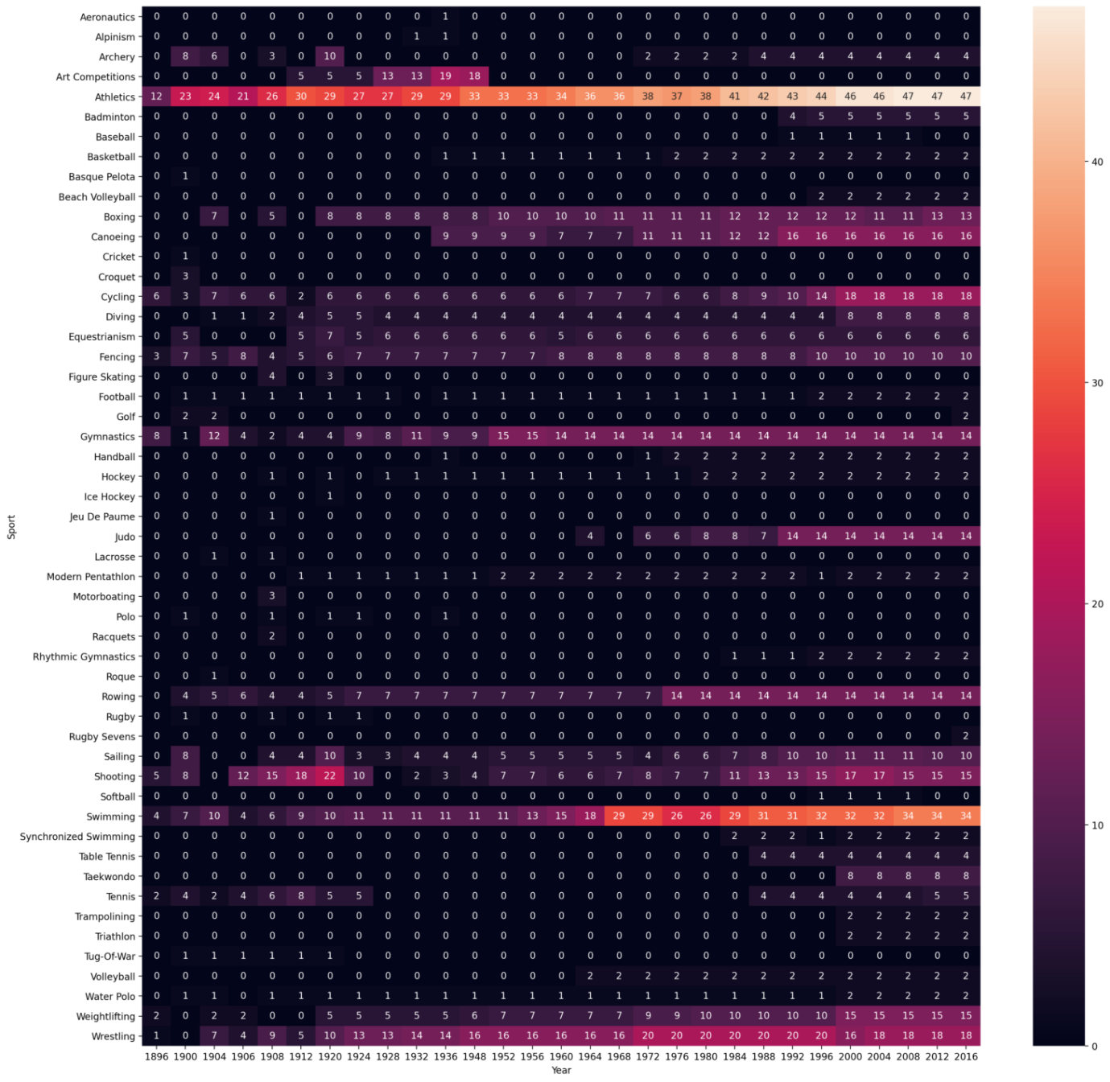

**Athlete wise analysis**

